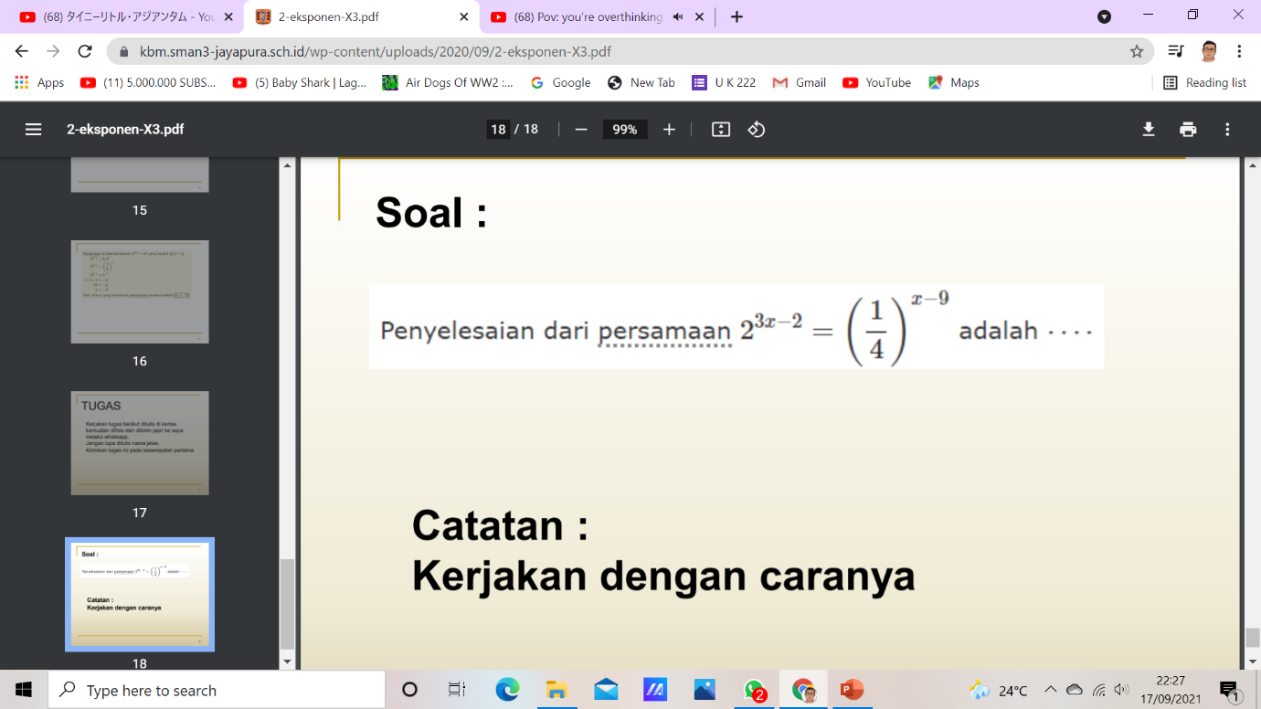

Cara kerja
2^{3x-2} =(1/4)^{x-9} =
3x-2= -2(x-9)
3x-2 = -2x+18
5x=20
x=4

